Regional Pest Management Strategy 2002-2022
For more information, contact Greater Wellington:
Masterton  PO Box 41  T 0800 496 734  F 06 378 2146  www.gw.govt.nz |  | Upper Hutt  PO Box 40847  T 0800 496 734  F 04 526 4171  www.gw.govt.nz |  |  |  |  |  | November 2018  www.gw.govt.nz  info@gw.govt.nz

Pest Animals and Pest Plants
Operational Plan Report 2017/18

Biosecurity Department

1. Introduction 3
Part One: Pest Animals 5
2. Surveillance Species 5
3. Total Control – Rooks 5
4. Suppression Species – Rabbits 8
5. Site-Led Species – Magpies 13
6. Site-Led Species – Human Health – Wasps 14
7. Site-Led – Key Native Ecosystems (KNE), Reserves and Forest Health 15
8. Site-Led – Biodiversity – Possum 22
9. Goodnature Trap Trials 23
11. Site-Led – Regional Possum Predator Control Programme 24
12. Public Enquiries 26
Part Two: Pest Plants 27
13. Regional Surveillance Species 27
14. Total Control Species 30
15. Containment Species 33
16. Site-Led Boundary Control, Suppression and Human Health Species 36
17. Site-Led – Key Native Ecosystems (KNE), Reserves and Forest Health 36
18. Biological Control 38
19. National Interest Pest Response Programme (NIPR) 40
20. Public Enquiries 41
Appendix 1 – Biocontrol agents released in the Wellington Region 41

1. Introduction

1.1 Biosecurity at the Greater Wellington Regional Council
The Wellington region is under threat from a number of pest animal and plant species. The Greater Wellington Regional Council (GWRC) is involved in the control of unwanted plants and animals because:
- Many of New Zealand’s native plants and animals cannot co-exist with introduced species. In areas of high biodiversity value, pest plants and pest animals need to be controlled to protect vulnerable ecosystems.
- Pest plants and pest animals cause considerable economic loss in many of New Zealand’s primary industries. Pest management is essential to the success of our agricultural and horticultural industries.
- Pest plants and pest animals are a nuisance to many aspects of rural and urban life, inhibiting the ability of people to enjoy their properties and inhibiting their wellbeing.
The Regional Pest Management Strategy 2002-2022 (RPMS) provides the strategic and statutory framework for effective pest management in the Wellington region. The central focus of the RPMS is on mitigating pest threats to society, to farming and agriculture in general, and supporting indigenous biodiversity and the ecological health of our ecosystems. There are two major objectives:
- To minimise the actual and potential adverse and unintended effect of pests on the environment and the community; and
- To maximise the effectiveness of individual pest management programmes through a regionally coordinated response.
Many advances in the effective management of a wide range of pest plants and pest animals have been made during the life of the Strategy. In response, indigenous biodiversity has been enhanced and local economic values protected over large parts of the region. The ability for this to be achieved was due to support from landowners, care groups and Territorial Authorities (TA).

1.2 How the pest species are decided
A cost-benefit analysis (CBA) is undertaken for all species proposed for the strategy. This process decides what control, if any, is to be undertaken and what level of management is needed for the species. The CBA works in conjunction with the infestation curve (Table 1), which designates the different management policies.

Graph 1. Pest infestation curve.
Infestation  phase | Phase characteristics | Management policies
Phase 1 | Potential pest not currently in the region | Regional Surveillance
Phase 2 | Recent arrival limited in distribution | Regional Surveillance
Phase 3 | Limited in distribution and density | Total Control
Phase 4 | Established but have not reached full distribution | Containment
Phase 5 | Widespread or entrenched in most or all available habitat | Suppression or Site-Led
Table 1. Phases of regional pest infestation through time.

1.3 Purpose of the Operational Plan Report
This document reports against the achievements and outcomes of GWRC’s biosecurity related activities. The work programme was set by the RPMS Operational Plan 2017/18 and aligns with the GWRC Annual Plan, which sets overall priorities and work programmes for the organisation.
Implementation of the RPMS requires resources. Our obligation to the community is to ensure these resources are used as efficiently and effectively as possible. This report provides some detail regarding how and where those resources were applied in the 2017/18 year.
The report is structured in two parts:
Part One - Pest Animals
Part Two - Pest Plants
The content is organised to align with the Operational Plan 2017/18. In the Pest Animal and Pest Plant sections, the aim, cost, means of achievement, and the actual performance is reported on for each pest species or management category.

Part One: Pest Animals
Species Led Programmes

2. Surveillance Species
Aim: To prevent the establishment or minimise the impact, and prevent the further spread, of animal Surveillance species in the region at a cost of $12,000.

Annual cost: The cost of Surveillance species management (monitoring, investigation, publicity and reporting) for the region was $9,200.
Means of achievement
Provide information and publicity to enhance public awareness of the surveillance species. The species in this category are Argentine ants, Australian subterranean termites, Darwin’s ant, rainbow skink and red-eared slider turtle.
Actual performance
Publicity around Argentine ants at Raumati South created a lot of interest and kept staff busy following up requests. Activities included a delimiting survey to gauge the extent of infestation, providing advice, and selling bait at cost price to landowners for ant control.
The infestation at Raumati South was a new site and from the work in this area more locations with Argentine ants have been detected. The ants are thought to have been brought to the area in infested pot plants. These ants can be dealt with by landowners combining efforts and baiting the entire infested area, and inspecting pot plants and soil before moving it around. An infested edge of Queen Elizabeth Park was treated for Argentine ants by our staff.
We are working with the Department of Conservation (DOC) and Kapiti Coast District Council (KCDC) to treat Argentine ants at the Paraparaumu boat club which is the loading point for visitors to Kapiti Island, and at other sites of interest such as helicopter pads and private owner’s residents on the mainland.
Social media posts instigated a biosecurity response in Happy Valley road. A dead adult wallaby was photographed in the gutter on Happy Valley road near Owhiro Bay school. It was posted on Facebook, but by the time GWRC staff made it to the site the wallaby was gone. Wellington City Council (WCC) and DOC were also involved, with Biosecurity staff spending time doing a night search with a thermal imager, and bringing in an indicator dog, however the wallaby was not recovered.

3. Total Control – Rooks
Aim: To manage rooks as a Total Control category pest to levels that protects production systems at a cost of $108,000.
Annual cost: The cost of rook management (surveys, research, compliance, education) for the region was $45,348.
Means of achievement
Undertake direct control by service delivery where rooks are known to exist.
Actual performance
Eight breeding rookeries were identified in the Wairarapa during 2017/18. This is three less rookeries than recorded in the previous two years. Between monitoring and control there were strong periods of north westerly winds but fortunately no nesting disruption appeared evident at active rookeries. Unsettled weather delayed the first round of nest baiting by several days, but 13 nests containing eggs or chicks were treated at seven rookeries on the 27 October. A subsequent baiting was carried out on the 6 November where a rookery with three nests holding eggs or chicks was treated.
The male rook is responsible for nest building and there has been an increasing trend of fresh but unused nests seen at active rookeries both in Horizon and Wellington regions. We feel that this is a reflection of the imbalance of males to females from years of repeated nest control. This year, 50 fresh but unused nests were recorded at the active rookeries.
The rook control programme remains on track to achieve total control of rooks in the Wellington Region by 2025. The number of treated nests has reduced from 150 in 2009/10 to 16 in 2017/18.
For a number of years, GWRC have not received any reports of rook damage to crops in arable farming regions. This indicates the success of the aerial baiting strategy.
Means of achievement
Annually survey rook populations in areas where they are known to exist, and where new infestations are reported.
Actual performance
There are presently 116 known rookery sites in the region, both historical and current. All known sites were visited to determine the presence or absence of rooks. Areas of likely habitat are also surveyed from helicopter when travelling to known rookeries with the aim of locating new colonies. Some ground surveys are followed by an aerial survey in spring to check for the presence/absence of nests with eggs or chicks.
The rook programme relies heavily on the public and landowners in the region to help with locating rooks. The control programme is publicised annually in newspapers urging the public to report sightings. One new rookery was reported by a landowner. Alongside this, three old rookeries had reactivated with the balance still active since control of the previous year. All rookeries were relatively small in size.
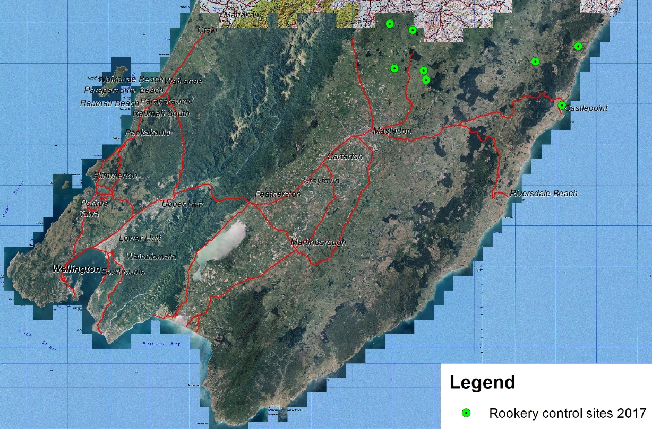
Map 1. Rookeries treated during the 2017 season.
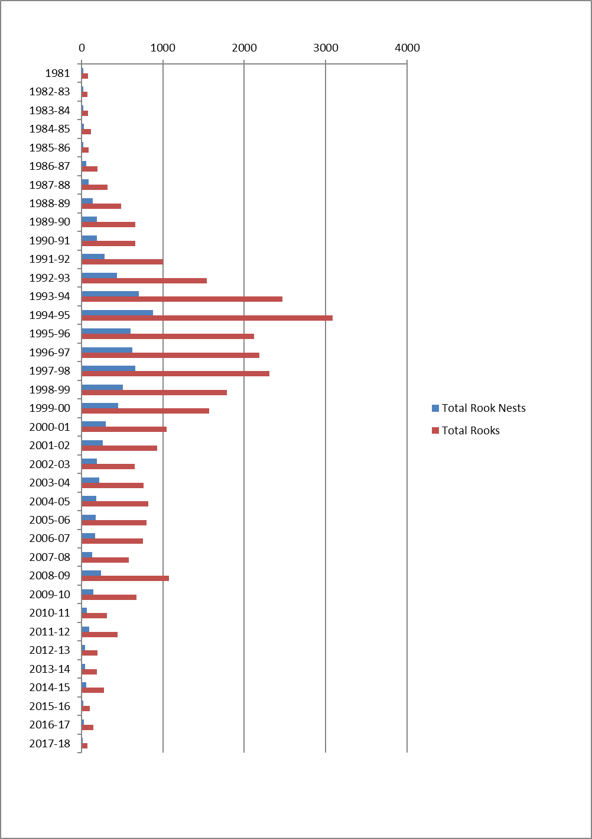
Graph 2. Total number of rookeries and number of rooks (estimated) in the Wellington Region.
Means of achievement
Ensure compliance with the RPMS rules.
Actual performance
The advertising campaign continues to remind landowners of their responsibilities when managing rooks. Private attempts at rook control can lead to rookery fragmentation and dispersal over a wider area. Rooks may also become bait shy if poisoning is attempted using inappropriate methods and baits. Public and landowner education is the key to ensure control is managed by GWRC.
Means of achievement
Encourage Horizons Regional Council to actively pursue management of rooks within their region that complements GWRC’s Total Control programme.
Actual performance
Horizons Regional Council was actively involved in aerial nest baiting in the 2017/18 year. Both GWRC and Horizons have cooperated in the annual joint nest baiting programme on both sides of the regional boundary. The programme is designed to prevent the southward migration of rooks into the Wairarapa.

4. Suppression Species – Rabbits
Aim: To minimise the adverse impacts of feral rabbits throughout the region at a cost of $216,000.
Annual Cost: The cost of rabbit management (surveys, service delivery, biological control, compliance, education and research) for the region was $219,000.
Means of achievement
Undertake direct control to manage rabbits on riverbeds, esplanades or similar public commons to ensure that rabbits do not exceed Level 5 of the Modified McLean Scale.
Actual performance
There were no situations in the region that required regulatory intervention. Most rabbit control undertaken during the year was to protect new plantings in re-vegetation projects by care groups, Territorial Authorities and private land owners. Regular night shooting in parks, reserves, beaches and cemeteries was undertaken for WCC, Hutt City Council (HCC) and KCDC and GWRC’s Akura Nursery. Costs for these activities were fully recovered. The use of the thermal imaging equipment has made these operations significantly more effective.
Means of achievement
Survey land in high to extreme rabbit prone areas to determine the extent of rabbit infestation.
Actual performance
A daytime survey of the Tauherenikau River and the adjacent properties was completed in May 2018 with rabbit numbers being very low. These surveys assessed rabbit abundance between Level 1 & 3 on the Modified McLean Scale. This river system historically produced hordes of rabbits that spread onto neighbouring stony free-draining farmland requiring periodic poisoning programmes to control numbers. The last intensive poisoning campaign was undertaken in the summer of 1993.
The rabbit prone areas of the Kapiti Coast, Wellington City and the Hutt Valley were also monitored in May 2018. Inspections have shown that rabbit numbers are again low in most areas, with small pockets of rabbits persisting around traditional hotspots.
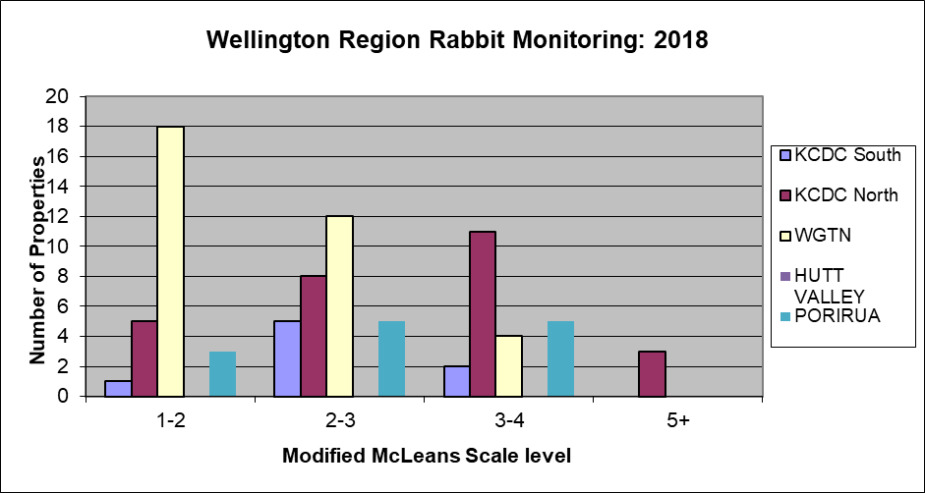

Graph 3. Modified McLeans Scale Level.

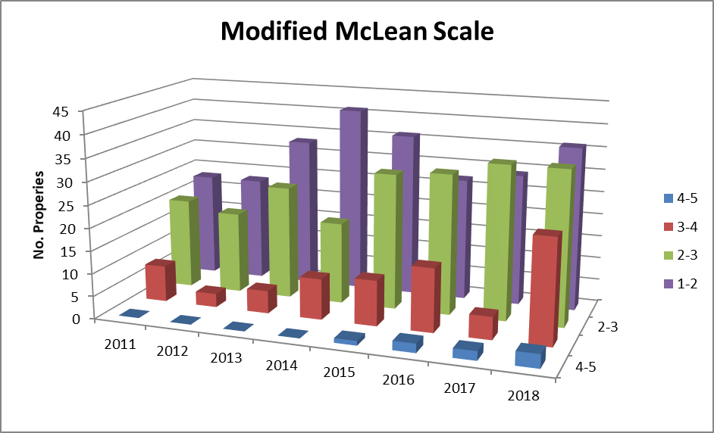
Graph 4. Rabbit property survey results 2011 – 2018.
Means of achievement
Release biological control agents for the control of feral rabbits when appropriate.
Actual performance
The current virus RHDV1 has continued killing feral rabbits in a few places throughout the region. A new strain of rabbit haemorrhagic disease virus (RHDV) known as RHDV1-K5 was approved for release in New Zealand in March and April 2018. The Wellington Region was included in this release, with GWRC releasing the virus at 32 sites across the region on 23 April 2018.
Prefeeding and night counts took place before the virus was released and night counts were re-done to assess effectiveness. The virus appears to have killed most rabbits that ate the bait directly. Post-release monitoring showed 16 sites had less rabbits, five sites had the same number of rabbits, and 11 sites had more rabbits.

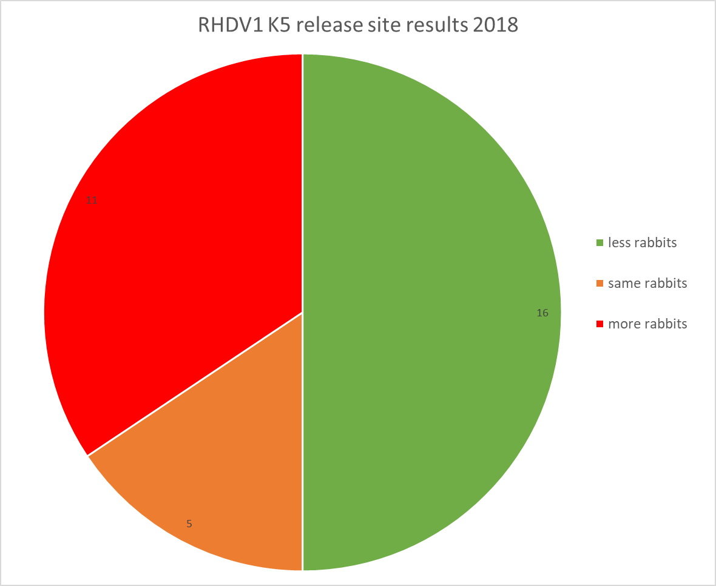
Graph 5. RHDV1 K5 release site results 2018.
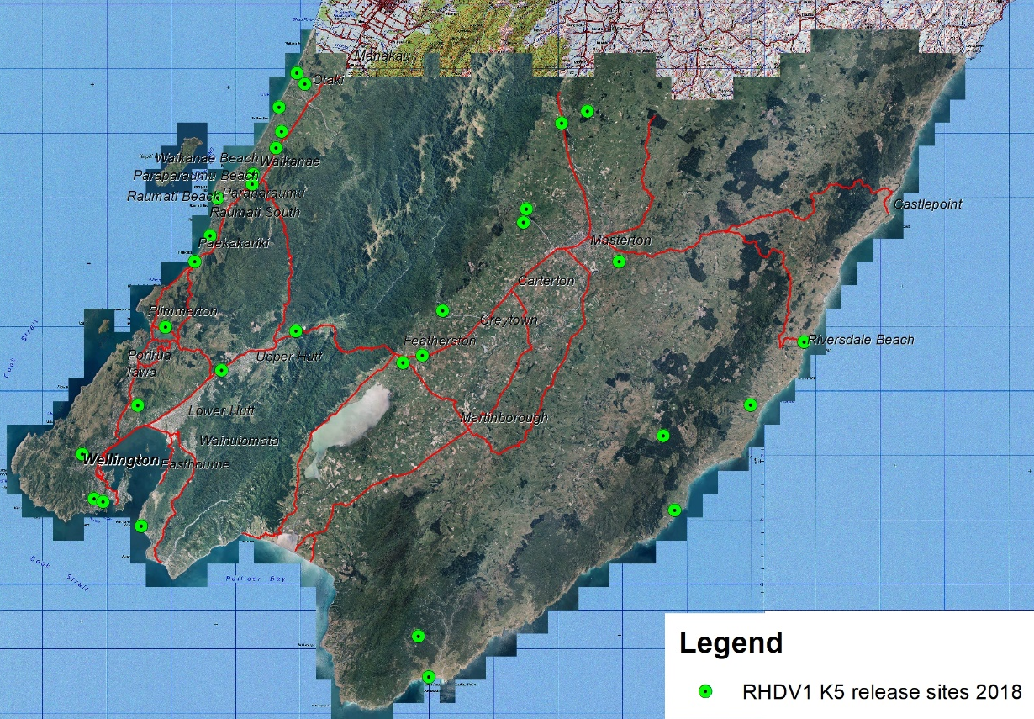
Map 2. RHDV1-K5 release sites 2018
On 15 May 2018, the Ministry for Primary Industries (MPI) confirmed that a new strain of the rabbit calicivirus RHDV2 had been discovered in a single wild rabbit found on Molesworth Station in the South Island. It was picked up by Manaaki Whenua Landcare Research (LCR) as part of routine sampling for research into the impact of RHDV1-K5.
The strain, called RHDV2, is widespread in Europe and Australia but had not previously been found in New Zealand. While they still don't know how widespread this strain is in New Zealand, the virus can spread rapidly, so there is a chance it is already prevalent in the wild. A rabbit from northern Wairarapa has since been confirmed as having also died from the virus.
Means of achievement
Support research initiatives including biological control.
Actual performance
Prior to the RHDV1-K5 release, a reduced amount of blood sampling was conducted (due to funding required for release of the K5 strain) in KCDC reserves and private land to assess immunity for RHDV1. Results showed a high level of immunity in the northern areas of the Kapiti Coast. Following the release, RHDV-K5 testing was done when dead rabbits were found. Results showed one confirmed case of death caused by the K5 strain.
Rabbit trend monitoring
Rabbit and hare night counts are conducted between May and July each year in Queen Elizabeth II Park (QEP) on the Kapiti coast, and on the Tora coast in the Wairarapa. The aim of the monitoring is to determine rabbit and hare populations at these two sites in the absence of formal control.
Monitoring for the 2017-18 year was not done in the Wairarapa (Tora coast) as the properties used for monitoring had restricted access due to the Mycoplasma bovis outbreak.
The counts in the QEP site showed an increase of roughly double the rabbit and hare numbers counted from last year.
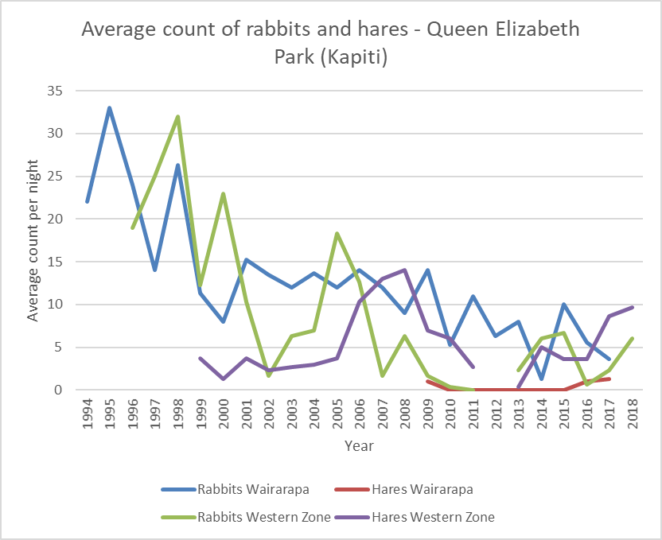
Graph 6. Average count of rabbits and hares in QEP (Kapiti) over three nights counting at 25 stations.

5. Site-Led Species – Magpies
Aim: To manage magpies to minimise adverse environmental and human health impacts in the Wellington Region at a cost of $65,000.
Annual Cost: The cost of magpie management to minimise adverse environmental and health impacts for the region was $37,400.
Means of achievement
Undertake direct control of magpies where there is known to be a threat of injury to members of the public, or, complaint(s) are made to that effect within 10 working days.
Actual performance
Ten (10) complaints were logged regarding magpies attacking public. All complaints were responded to within 10 working days including capture and destroying the magpie(s) involved in some cases.
Means of achievement
Respond to landowners wanting to undertake magpie control within 15 working days of receiving a request for information and/or assistance.
Actual performance
During the 2017/18 we received 29 calls and all calls had response times within 15 working days. Staff provided advice on best practice trapping techniques to maximise catches, and had loan traps available.
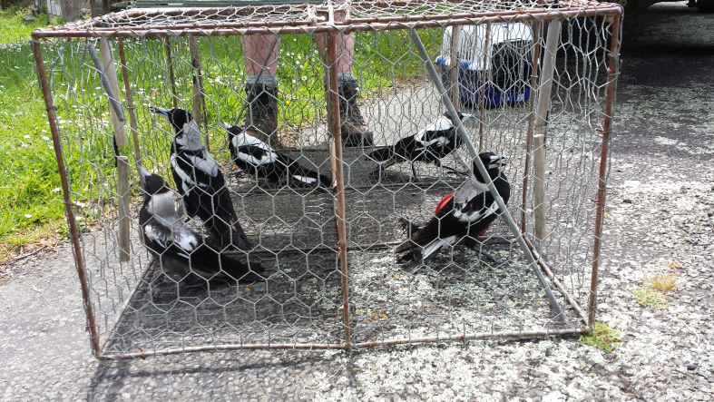
Image 1. Multi-catch magpie trap loaned to private landowners full of caught magpies.

6. Site-Led Species – Human Health – Wasps
Aim: To minimise the adverse human health and environmental impacts of wasps at selected sites at a cost of $7,000.
Annual Cost: The cost of wasp management to minimise the adverse human health and environmental impacts for the region was $18,400.
Means of achievement
Provide advice and education to occupiers wanting to undertake wasp control.
Actual performance
GWRC continues to contribute funding to the National Wasp Research Collective. The research focussed on potential biocontrol agents and a mite recently found on Vespula wasps in New Zealand as a form of biocontrol. The Sustainable Farming Fund programme led by Manaaki Whenua – Landcare Research (in conjunction with a support group in the upper South Island) has been awarded funding for another three years to enable the identification of novel biocontrol agents for wasps. There will undoubtedly be other wasp-infested nations watching with interest.
This project initially explored the potential for a mite, Pneumolaelaps niutirani, found on the wings of wasps to provide perpetual control at a landscape scale. While it was found that this was unlikely to be effective as a classic biocontrol, the work with the mite, in conjunction with wasp-specific pathogens will continue under the Biological Heritage National Science Challenge. In addition, the Collective re-introduced new genetic stock of the parasitoid Sphecophaga from the UK. These were collected along with wasp parasite hoover flies Volucella zonaria and Volucella inanis, and Metoecus paradoxus beetles. Unfortunately over wintering of these organisms in laboratory proved difficult and only a fraction of the flies emerged after winter, threatening the success of the biocontrol programme.
Wasp season 2017/18
There were 16 human health complaints from occupiers about neighbouring wasp nests affecting them. This is an increase from previous years. It may reflect the change in our reporting process and favourable weather conditions.
Various Territorial Authorities, DOC and GWRC respond to wasp nest nuisance calls within the Wellington Region. All calls have been recorded in the ‘Wasp Nest Register’ since 1990/91. A sharp increase for the 2017-18 season is a change from recent years. The amount of calls regarding wasp nests to GWRC and various TAs is indicative of a favourable season weather wise (Graph 7).
All Biosecurity department Pest Animals staff became registered users of the new wasp bait Vespex which came on the market in December 2015. Biosecurity staff have trialled the product in random sites to test the accepted prognosis from other organisations is that it is only really effective in beech forests with little other food availability.
The large willow aphid infestations in the region are likely to drive wasp numbers up with the right climatic conditions. The aphids cause the secretion of large amounts of honeydew from willow trees, creating a food source for wasps, which leads to increased wasp activity near areas with willow trees. Treatment options will vary depending on the site.
We are working with the community to enable them to treat wasps and nests. We do this through the website, social media and at open days, sharing information, discussing technique and building traps.
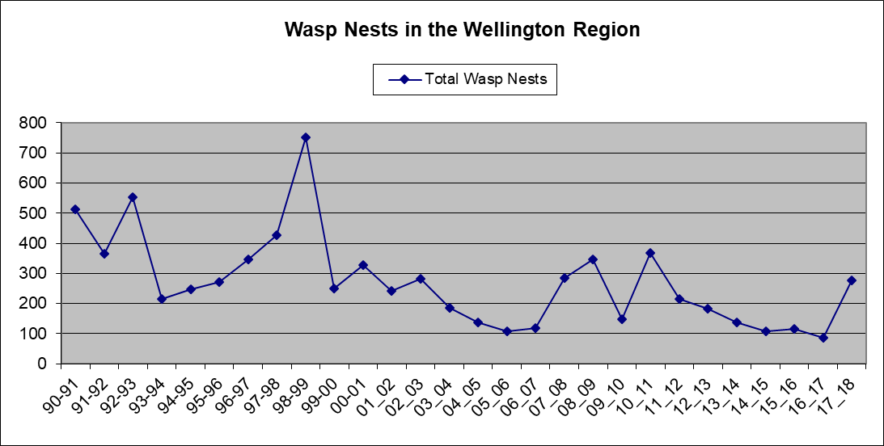

Graph 7. Wasp nuisance nest calls for the Wellington Region.

7. Site-Led – Key Native Ecosystems (KNE), Reserves and Forest Health
Aim: To protect indigenous biodiversity in a comprehensive selection of Key Native Ecosystems and reserves at a cost of $1,654,000.
Annual Cost: The cost to achieve a measurable improvement in the ecological health and diversity of Key Native Ecosystems and reserves through pest animal control was $1,812,000.
Means of achievement
Establish and implement integrated pest management plans for all KNE sites and selected reserves.
Actual performance
KNE operational plans are being produced for all 58 KNE sites that identify pest management requirements at each KNE site.
Means of achievement
Undertake direct control by service delivery of pests identified in the management plan for each KNE site.
Actual performance
During the 2017/18 year, pest animal control of possums, rats and/or mustelids was undertaken at 51 of the 58 KNE sites.
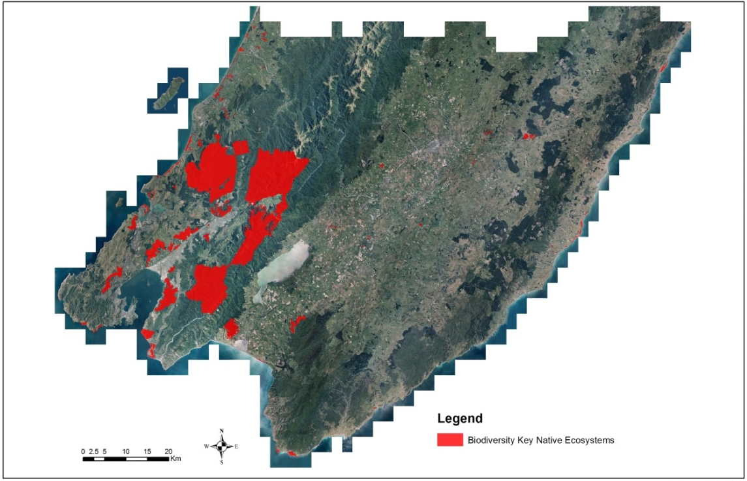
Map 3. Sites managed as part of GWRC’s Key Native Ecosystem (KNE) programme in the Wellington Region 2017/18.
Case Study: Parangarahu Lakes
As a result of intensive and refined trapping and night shooting, no dotterel nests at the Parangarahu Lakes Block were predated on. This is a really big reward for the huge amount of effort by volunteers and staff. A huge amount of learning has occurred and best practise trapping methods refined to suit the suite of pests and harsh coastal environment. This learning is now being used to improve trapping along the same coastline and at Baring Head, another site where dotterels nest.
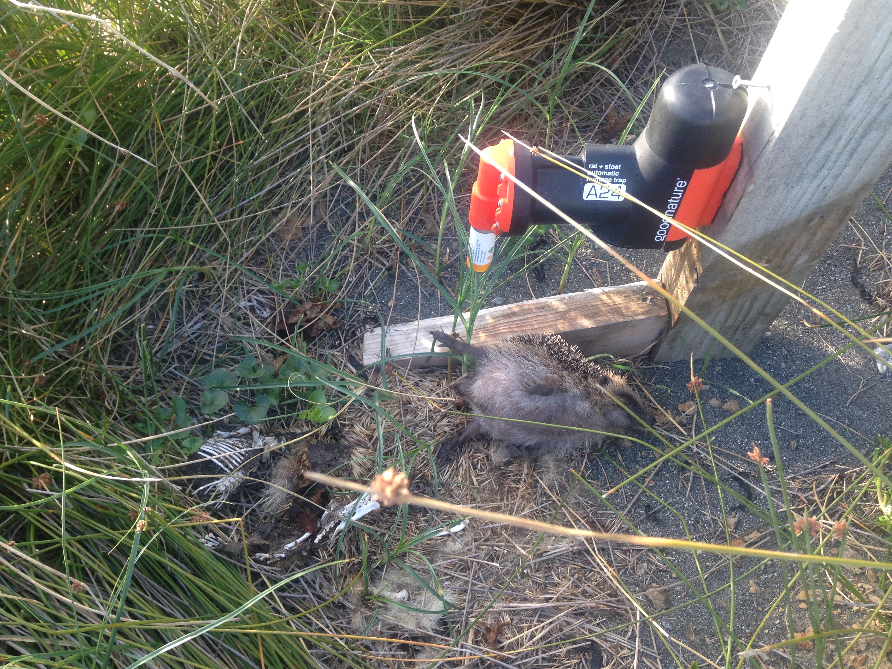
Image 2. Ramp system to allow hedgehog kills to roll away from the trap entrance (Goodnature A24 traps).

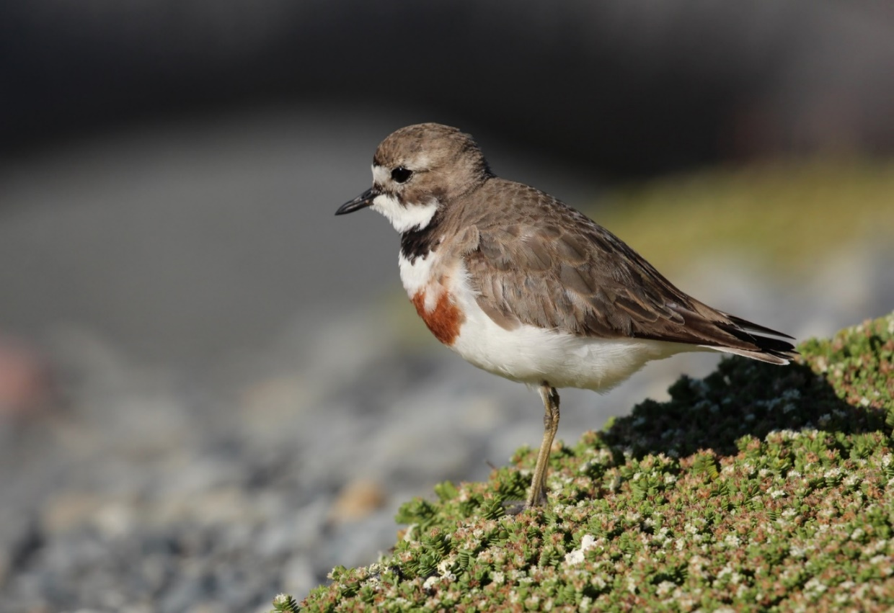
Image 3. Banded dotterel at Parangarahu Lakes.

Means of achievement
Where KNE sites are identified on TA land, seek funding from the relevant authority to form financial partnerships.
Actual performance
GWRC maintains good working relationships with all of the regional TAs, including a number of shared funding agreements for pest management. Memoranda of Understanding (MOU) provide a formal platform for these relationships. The MOU is prepared and agreed between GWRC’s Biodiversity and Biosecurity departments and the relevant TAs (annual agreements – Hutt City Council, Upper Hutt City Council, Kapiti Coast District Council, Porirua City Council; longer term agreements – Masterton District Council, Wellington City Council). The parties agree to support biodiversity and optimise ecological health within the relevant territories. This is further confirmed and supported by agreeing pest control work and budgets in each KNE plan.
Means of achievement
Coordinate site management with other biodiversity initiatives, where possible.
Actual performance
KNE operational plans identify all management partners and relevant stakeholders and GWRC works collaboratively with these groups to coordinate site management.
Pest animal control is undertaken with volunteers to assist them in achieving a range of biodiversity based objectives. This continues in a wide range of Territorial Authority (TA) reserves and KNEs across the region.
Means of achievement
Undertake direct control of feral and unwanted cats by service delivery as part of the integrated pest management of KNE and other selected sites.
Actual performance
Feral and unwanted cats are actively managed in 19 KNE sites within the Wellington Region. These sites are predominantly rural, as the high number of domestic cats in urban areas prevents the use of current cat management techniques. GWRC also works in conjunction with TA’s and private landowners to manage feral and unwanted cat populations.
Means of achievement
Work with communities to remove populations of stray or unwanted cats.
Actual performance
Individuals who wish to remove stray or feral cats from their own land are given advice on control options, offer of materials at cost price or referred to commercial pest management operators.
WCC have had bylaw changes to introduce compulsory microchipping. Until pet cats can be identified, control of feral or stray populations is almost impossible anywhere near urban areas.
Means of achievement
Reduce densities of select Site-led biodiversity species (feral deer, feral goats, and feral pigs) in KNE sites and TA reserves.
Actual performance
Another successful year of ungulate control has concluded with 320 feral goats, 31 feral deer and 173 feral pigs being destroyed. Control was undertaken in Wainuiomata Mainland Island, Wainuiomata/Orongorongo Catchment, East Harbour Regional Park, Hutt Catchment, Kaitoke, Pakuratahi, and Akatarawa. Aerial control was successfully undertaken in February, and the Judas goat in Kaitoke was re-collared. Requests were made by the hunting team for more hunting time in several areas, in particular Pakuratahi, to counter the increasing reinvasion rates from DOC land.
GWRC staff have undertaken feral goat control in several KNE sites and assisted WCC with pig control work around urban areas.
Means of achievement
Facilitate the involvement of community groups, where appropriate.
Actual performance
GWRC has been involved with community groups undertaking pest control for many years. Several KNE sites benefit significantly from the enthusiasm and resources of community groups. Groups have been carrying out plantings, pest control, monitoring and ecological surveys, and fundraising to support the management of KNE sites.
Pest control involvement continued in 2017/18 with the Biosecurity team having involvement with groups, participating at 22 sites, and private landowners doing their own control at four sites in the KNE programme and numerous other QEII covenant sites.
Legends of pest control operations, Allan and Glennis Shepard, have retired from servicing bait stations and traps. Areas they have been involved in, the Keith George KNE, Wi Tako KNE, Maidstone Park, Tunnel Gully, and Trentham Memorial Park KNE, have benefited greatly from their efforts.
Predator Free Wellington
Predator Free Wellington Ltd (PFWL) is a joint venture between Wellington City Council, Greater Wellington Regional Council, the NEXT Foundation and Central Government funders - PF2050 Ltd. While this is a technical challenge bringing innovation and creativity to the fore, it is also a social challenge with success dependent upon the community connecting with the goal and seeing themselves as part of this uniquely Wellington story.
Wellington is at the forefront of a remarkable social movement with 44 suburbs having established community led backyard trapping groups involving tens of thousands of households contributing to the shared vision. This is further reinforced by over 120 community groups working in reserves in the broader ecological restoration space. A comprehensive social survey of Wellingtonians completed in March 2017 showed 84% support for the eradication goal. We are working off a strong mandate from the public.
PFWL builds on a 20 year programme of integrated predator control and broader ecological restoration undertaken in reserves and rural landscapes in partnership between WCC, GWRC and communities.
The success of this project will provide a huge milestone in the national context of achieving a Predator Free New Zealand by demonstrating that eradication of multiple species can be achieved in both the urban and commercial context right here in our capital city. This ground breaking project will prove if eradication is possible in complex urban environments and, if successful, will inspire other urban communities across New Zealand and internationally.
The first phase of the project is to launch a full scale eradication operation on the Miramar Peninsula in the winter of 2019, before moving into the CBD and beyond in subsequent years. Securing the peninsula against re-invasion through an effective barrier zone is absolutely critical to ensure the gains are not lost. To achieve this, PWFL has partnered with Zero Invasive Predators Ltd (ZIP) and are in the process of engaging key stakeholders in the development of potential options.
In the 2017-18 year GWRC staff have been involved with:
- Developing an eradication plan and price to eradicate Miramar Peninsula of rats and mustelids
- Planning and implementing another 200m x 200m chew card monitor across the Miramar Peninsula and Wellington International Airport land with the assistance of volunteers to assess the pre-control predator numbers
- Preparing a monitoring plan for the Predator Free Wellington project, incorporating detection monitoring and outcome monitoring to assess the benefits of the programme for local native species.
Means of achievement
Monitor site recovery using a range of ecological indicators.
Actual performance
In order to better understand pest mammal dynamics and to ensure that small mammal control is effective, monitoring of rodents and mustelids is carried out at a sub-set of KNE sites. Small mammal monitoring was conducted at eight KNE sites (Map 4) during 2017/18.
An aerial 1080 possum control operation is planned to be undertaken in the Wainuiomata/Orongorongo KNE site during the spring of 2018. Officers doing the operational planning are taking advantage of the expected benefit of this operation, in the way of suppression of possum and rat populations, by pausing ground based possum and rat control and diverting funding from these into the maintenance and improvement of the pest control infrastructure. Possum traps and rodent bait stations were last re-baited in December 2017. Rebaiting of these traps and bait stations will resume three months after the aerial operation. This pause in control has led to an increase in rat tracking rates from a low of 6% in February 2018 to 32% in May 2018. Mice tracking rates have remained at low levels in both the Mainland Island and the non-treatment area. This may be due to the extreme rat tracking rates interfering with mice activity.
In the East Harbour Northern Forest KNE site the rat tracking rate in the non-treatment area has increased from its peak 28% in February 2017 to 50% in May 2018. In the Mainland Island rats have remained at low levels reaching 8% in May 2018. Mice tracking rates have stabilised below the 10% tracking rate in both the Mainland Island and the non-treatment areas.
The tracking rates for rats were relatively low in most other monitored forest sites. Belmont Korokoro (12%) Wellington Western Forests – Otari (3%), Porirua Western Forests (13%) KNE sites. The exception is at Wellington Western Forests – Johnsonville Park where the tracking rate increased to 35% in June 2018 (refer Section 9 for detail about this trial).
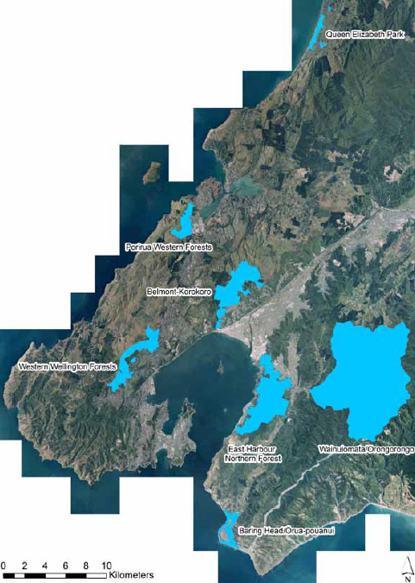
Map 4: Key Native Ecosystem small mammal monitoring sites.

8. Site-Led – Biodiversity – Possum
Aim: To minimise the adverse impacts of possums in areas of ecological significance (outside of the KNE programme) and maintain accrued biodiversity and economic gains in the Wellington Region at a cost of $132,000.
Annual cost: The cost for minimising the adverse impacts of possums in ecologically significant areas and maintaining current biodiversity and economic gains in the Wellington Region was $141,500.
Means of achievement
Undertake direct control by service delivery in sites of ecological significance (outside of the KNE programme) in agreement with the landowner/occupier.
Actual performance
GWRC supported landowners who undertook possum control in QEII covenanted sites across the region. Bait, traps and advice are provided by Biosecurity staff through the local QEII representatives, with the Biodiversity department covering the cost of the equipment up to $2000.
Service Delivery - Cost Recovery
GWRC undertakes a range of advice and cost recovery possum and rat control work outside the KNE programme for local TAs and private landowners.
TA work undertaken for: | Number of control sites | Target pest animals controlled | Cost recovered
Wellington City Council | 20 | Possums, rats, mustelids, rabbits | $261,000
Hutt City Council | 3 | Possums and rats | $32,000
Kapiti Coast District Council | 4 | Possums, rats, mustelids | $8,000
 |  | Total | $301,000

Table 2. Cost recovery work undertaken for Territorial Authorities.
Means of achievement
Provide a referral or cost recovery service to landowners/occupiers who require possum control.
Actual performance
GWRC provides assistance and advice on the management of possums to individual property owners, usually in urban or peri-urban situations, with materials at cost price. Assistance is usually with the intent that the occupier can self-manage any future possum problems. Nuisance possums can sometimes be managed in conjunction with, or, as an extension to our existing possum control areas.

9. Goodnature Trap Trials

9.1 Johnsonville Park
In the bid to improve pest animal control methodology, GWRC is continually experimenting with new control techniques always aiming to achieve more effective control and minimise the use of toxins.
In Johnsonville Park attempts are being made to get the Goodnature A24 traps working at greater spacing than recommended, using the same spacing as poison bait stations. This has been an ongoing project for over four years, trialling innovative solutions. We now have enough information to prove that the A24 traps spaced at 150m intervals cannot maintain rat numbers at our target 5% tracking rate, therefore the next phase is to move the traps closer together at 100m intervals. Through our collaboration with the manufacturer, trap and lure reliability improved significantly with only 3 out of 100 traps serviced running out of gas.
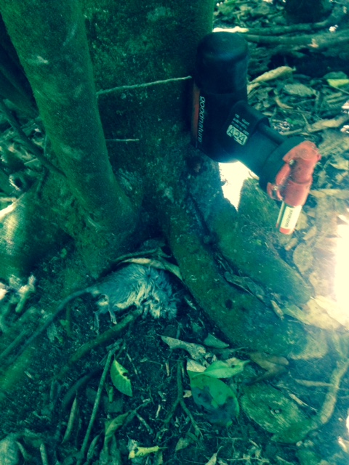

Image 4. A24 customer at Johnsonville Park.

9.2 Te Ahumairangi
On Te Ahumairangi (Tinakori Hill), A24 traps for rat control were installed in July 2016. Rats have been maintained at almost undetectable levels since November 2016. The trapping grid is tighter than a poison bait station network. The perimeter of bait stations was discontinued in March 2018. This will be bolstered with 69 additional A24 traps at the same 150 x 75m spacing to see if it can hold the line with re-invasion from urban areas.
Monitoring for possum activity continues with wax tags and chew cards used at every service with no detections to date.
 | 15/06/16 | 13/10/16 | 15/02/17 | 16/05/17 | 11/09/17 | 20/12/17 | 26/03/18 | 4/10/18
Rats | 2 | 5 | 0 | 0 | 5 | 1 | 6 | 3
Mice | 5 | 1 | 0 | 0 | 2 | 0 | 0 | 0
Hedgehog | 0 | 4 | 1 | 0 | 1 | 5 | 9 | 3
Rodents | 7 | 6 | 0 | 0 | 7 | 1 | 6 | 3
Rodent % | 17.5 | 15 | 0 | 0 | 17.5 | 2.5 | 15 | 7.5
Rat % | 5 | 12.5 | 0 | 0 | 12.5 | 2.5 | 15 | 7.5

Table 3. Tracking tunnel monitoring results

9.3 Project HALO
The network of A12 traps in this area is failing to control possums with the current hands-off approach. Each time traps are serviced (freshly lured and baited) there is a spike in kills. Further lure and trigger development needs to occur for the A12 to be a long-term effective control option.
A24 and A12 traps have been installed along the Zealandia fence as part of the Wellington City Council funded ‘Project HALO’ operation. Should the fence be damaged in a storm, these traps will help to reduce incursions, particularly rats.

11. Site-Led – Regional Possum Predator Control Programme (RPPCP)
Aim: To minimise the adverse impacts of possums in areas declared Bovine Tb free or in areas which are outside of the Tb Free New Zealand programme at a cost of $1,395,000.
Annual cost: The cost for minimising the adverse impacts of possums in the RPPCP areas of the Wellington Region was $ 1,368,000.
Means of achievement
(i) Address the adverse impacts of possums in bovine Tb free areas for catchment functions, biodiversity and economic prosperity
(ii) Maintain a possum residual trap catch (RTC) of 5% or lower across the Wellington Region in areas which have been declared bovine Tb free
(iii) Commence possum control in areas not included within the Tb Free New Zealand programme.
Actual performance
The Regional Possum Predator Control Programme (RPPCP) for the Wellington Region covers approximately 138,900 ha which include new projects within the Whangaehu, Bideford and Tinui areas of the Masterton District.
In the 2017/18 year 92,800 hectares were treated for possum control. Seven projects were monitored and the annual Residual Trap Catch index was 0.9% (vs maximum target limit of 5%).

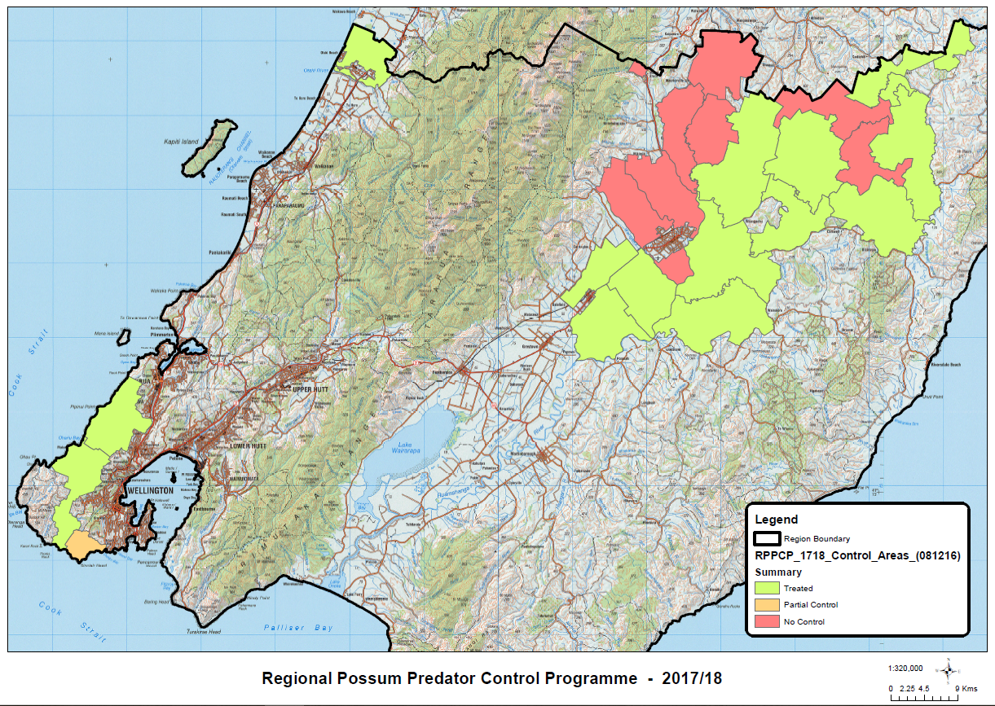
Map 5. Regional Possum Predator Control Programme 2017-18.

12. Public Enquiries
Responding to public enquiries is a significant focus of the Operational Plan. This year we received and processed 812 public pest animal related enquires, compared to 476 the previous year. There is a real surge in interest regarding pest animals and their control.
The increase of activity can be contributed to the Predator Free movement and to the implementation of the Ozone database meaning that public enquires are accurately recorded. With the increase in enquiries there is now a roster dedicating one staff member to this task each week to ensure customer responses are timely.
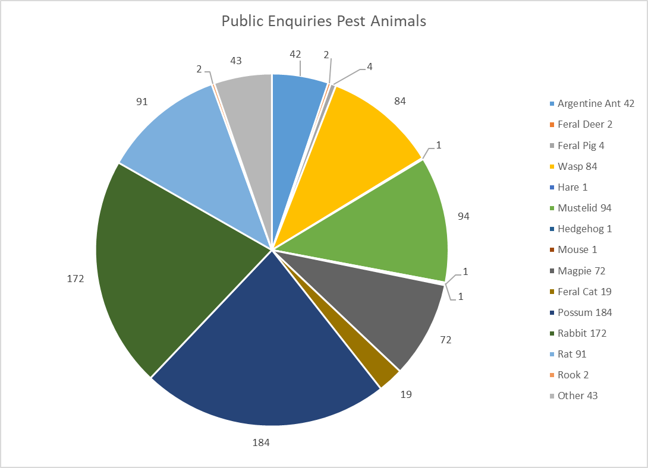

Graph 8. Client response activity Pest Animals 2017-18 year.

Part Two: Pest Plants

13. Regional Surveillance Species
Aim: To determine the distribution and means of control for Regional Surveillance pest plants within the Wellington Region at a cost of $270,000.
Annual cost: The cost of managing Regional Surveillance plants throughout the region during 2017/18 was $129,800.
Means of achievement
Identify new sites of Regional Surveillance pest plants by GWRC staff, the public, or through the Regional Surveillance programme.
Actual performance
There are 34 Regional Surveillance species listed in the RPMS. To date, only 12 species have been discovered in the Wellington Region (Shown in Table 4).
Thirteen new sites with a Regional Surveillance species infestation were discovered this year: chocolate vine (4), purple loosestrife (2), Senegal tea (5), water hyacinth (1) and white edged nightshade (1). This brings the total number of known sites with Regional Surveillance species in the last 10 years to 307.
Plant name | Number of sites | Found this year
African fountain grass | 1
Asiatic knotweed | 29
Bomarea | 26
Cape tulip | 34
Chilean flame creeper | 3
Chocolate vine | 140 | 4
Nassella tussock | 1
Purple loosestrife | 26 | 2
Senegal tea | 14 | 5
Spartina | 2
Water hyacinth | 6 | 1
White edged nightshade | 12 | 1
Total: | 307

Table 4. Number of sites with Regional Surveillance species in the Wellington Region over the previous 10 years.
Means of achievement
Undertake a control trial programme on selected Regional Surveillance pest plants within the region.
Actual performance
All known purple loosestrife sites in the Wairarapa were ground truthed along with any sites where previous sightings or reports had been recorded.
An extensive survey was also carried out around the newly created wetlands along the Kapiti expressway. The known purple loosestrife sites within the construction path of the Kapiti expressway have been destroyed during construction, and no new sites of purple loosestrife were found.
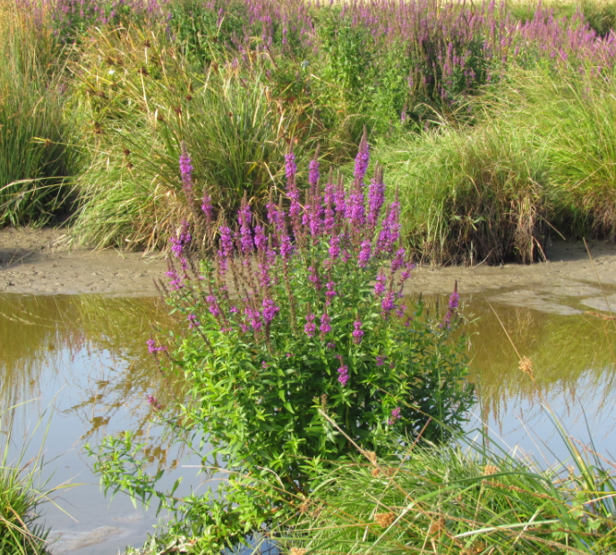
Image 5. Purple loosestrife in flower Boggy Pond, South Wairarapa.
Spartina was controlled around Lake Onoke by contractors managed by DOC, and a site audit was undertaken by GWRC staff to assess their work. All historic spartina sites were also monitored to check for presence/absence.
Means of achievement
Use biological control agents where appropriate, and support relevant biological control research initiatives.
Actual performance
GWRC is part of the National Biological Control Collective (NBCC) along with a number of other councils, DOC and MWLCR. The NBCC is currently funding research into biocontrol agents for a range of pest plants including some Regional Surveillance species.
Means of achievement
Provide information and publicity to enhance public awareness of the threat posed by Surveillance species to the region.
Actual performance
A factsheet for each Regional Surveillance species can be found on the GWRC website.
Post 1: 1880 reach, 17 reactions, 4 shares, 35 clicks  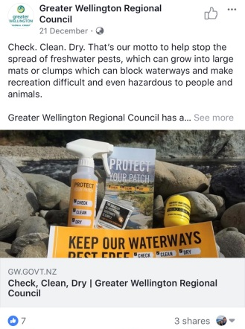 | Post 2: 974 reach, 4 reactions, 1 share, 7 clicks  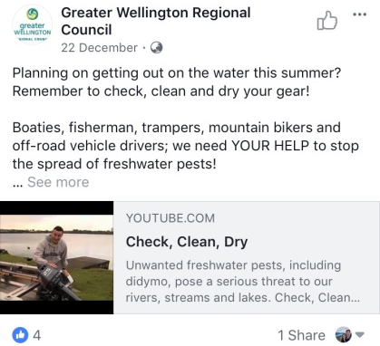 | Post 3: 12k reach, 122 reactions, 17 comments, 1k clicks  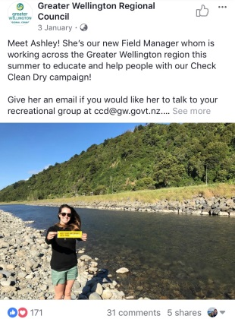
Post 4: 8k reach, 46 reactions, 12 comments, 325 clicks  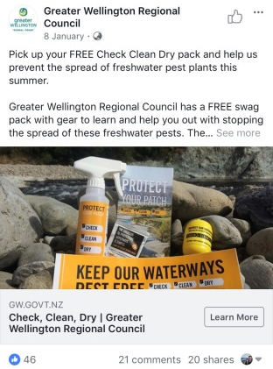 | Post 5: 3400 reach, 31 reactions, 5 shares, 372 clicks  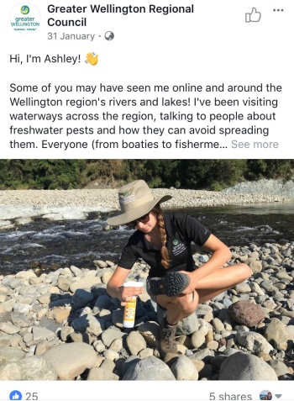 | Post 6: 1600 reach, 6 reactions, 57 clicks  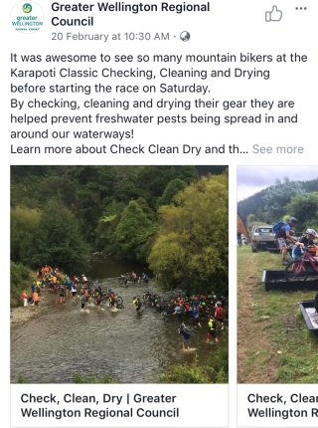
The Ministry for Primary Industries continued their funding of the Check, Clean, Dry (CCD) programme for the tenth consecutive year. The aim of the programme is to raise public awareness of didymo and other freshwater pest species, and the risk they pose to our waterways. A regional advocate is employed to engage with the public by targeting high-use areas of our rivers, attending specialist outdoor events and looking at new ways to engage the public. A number of targeted adverts were sent out via social media which generated good uptake and views from the public. Two schools were also visited and an interactive lesson was held. Collateral information was handed out to relevant organisations, businesses and clubs.

Image 6. Check, Clean, Dry social media posts.

14. Total Control Species
Aim: To control all Total Control species within the Wellington Region at a cost of $363,000.
Annual cost: The cost of managing Total Control plants throughout the region during 2017/18 was $306,900.
Means of achievement
Identify new sites of Total Control species through incidental reports by GWRC staff, the public, or through the Regional Surveillance programme.
Actual performance
This year 26 new sites of Total Control species were discovered (one Bathurst bur, six blue passionflower, six climbing spindleberry, six moth plant and seven woolly nightshade). This brings the overall number of Total Control species sites to 1,257 (Table 5).
This year 2,274 individual properties were inspected during Total Control species delimiting surveys. Delimiting surveys require the inspection of all properties within a specified distance, usually 200m from a known infestation site, in an attempt to locate further sites of a targeted species.
Plant name | Sites in total | New sites found this year
African feathergrass | 102
Bathurst bur | 17 | 1
Blue passionflower | 466 | 6
Climbing spindleberry | 71 | 6
Eelgrass | 91
Moth plant | 261 | 6
Perennial nettle | 90
Saffron thistle | 10
Woolly nightshade | 149 | 7
Total: | 1257 | 26

Table 5. Number of sites of Total Control species in the Wellington Region.
Means of achievement
Undertake direct control by service delivery of all Total Control species at all known sites within the region on an annual basis.
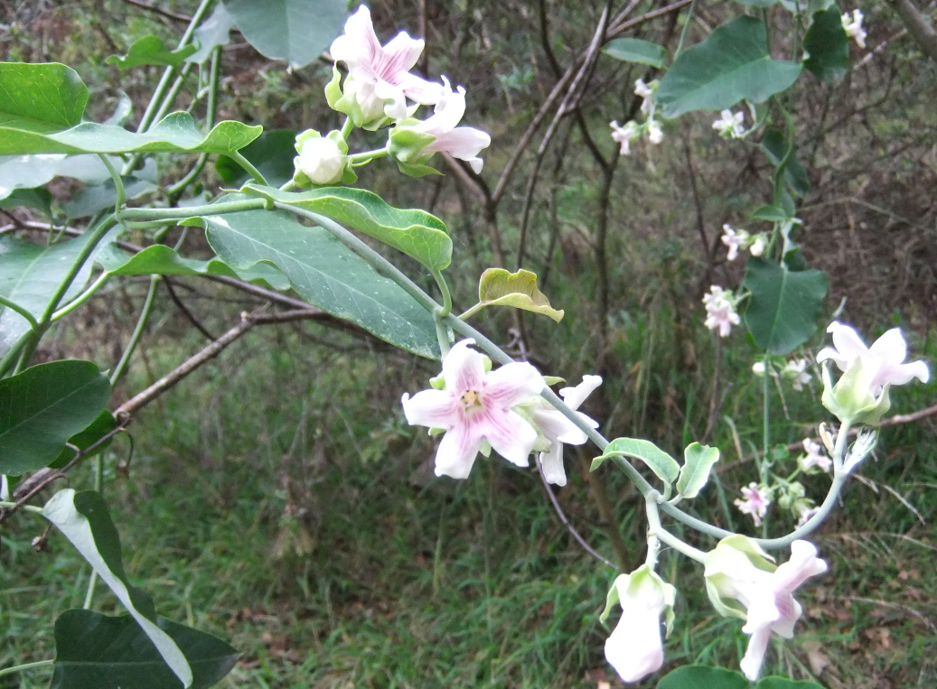
Image 7. Moth plant in flower.
Actual performance
A total of 787 annual inspections on the following Total Control species were undertaken: climbing spindleberry, eelgrass, moth plant, and woolly nightshade, with any plants found being controlled. The remaining Total Control species: African feathergrass, Bathurst bur, blue passionflower, perennial nettle and saffron thistle were all subject to delimiting surveys instead of annual inspections to obtain data needed in preparation for the review of the Regional Pest Management Plan 2019 – 2039 (RPMP). Bathurst bur sites were inspected and controlled where there was any risk of spread to other sites through crop movement on the property.
A total of 274 adult Total Control plants were found over 43 properties (17 of these were new sites). Also, 1,816 seedlings of Total Control pest plant species were controlled over 80 properties.
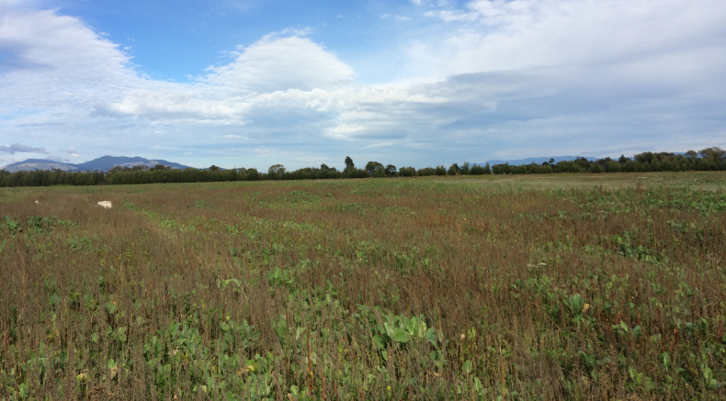
Image 8. One of the many crops that were searched for Bathurst bur.
Means of achievement
Annually inspect all plant outlets and markets within the region to ensure no RPMS and National Pest Plant Accord (NPPA) species are being offered for distribution, sale or propagation.
Actual performance
Staff inspected 104 plant outlets and markets in the region for plant species listed in the RPMS and NPPA and all outlets were compliant.
Means of achievement
Use biological control agents where appropriate, and support relevant biological control research initiatives.
Actual performance
The NBCC is currently undertaking research into finding suitable biocontrol agents for two Total Control species: moth plant and woolly nightshade.

15. Containment Species
Aim: To control all Containment species outside the Containment zones within the Wellington Region at a cost of $179,000.
Annual cost: The cost of managing Containment plants throughout the region during 2017/18 was $339,300.
Means of achievement
Undertake direct control by service delivery of Containment species outside the Containment zone within the region on an annual basis.
Actual Performance
Biosecurity staff continue to inspect and control all known boneseed sites outside areas determined as Containment zones. The programme has made considerable progress in reducing the number of boneseed plants setting seed, with the team often working in difficult terrain and under demanding conditions. Control areas are located in coastal Wairarapa, Titahi Bay and on Wellington’s south coast.
Staff controlled 326 adult boneseed plants over 34 sites (five (5) of these sites were new). Total of 4,066 boneseed seedlings were also controlled over 75 properties, and overall 10 new sites were found this year.
Boneseed, evergreen buckthorn and sweet pea shrub were controlled whenever they were found outside the Containment zones. This mainly occurred on dunes and escarpment ecosystems.
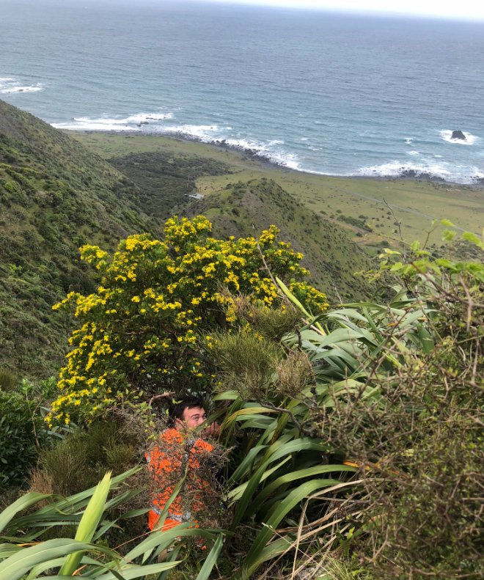
Image 9. An example of the terrain where boneseed control takes place, Cape Palliser, South Wairarapa
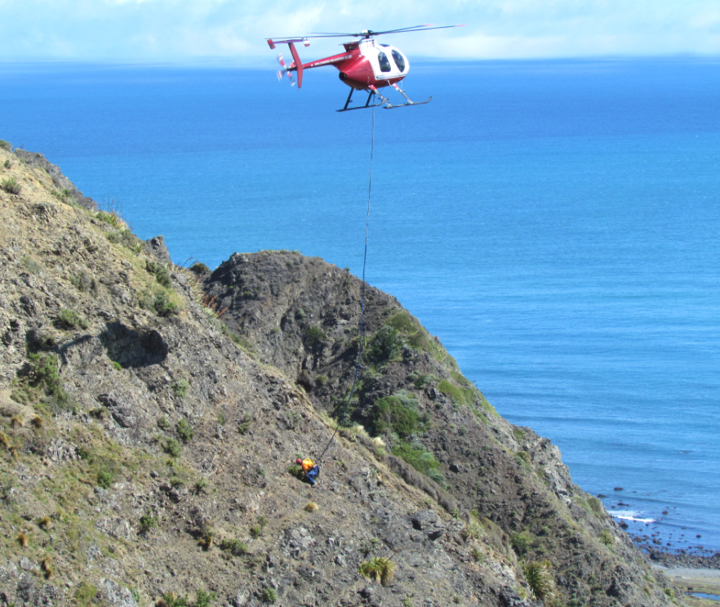
Image 10. Aerial control of boneseed continues on the coastal escarpment at Ngawi, South Wairarapa.
Means of achievement
Provide information and publicity to enhance public awareness of the threat posed by the Containment species to the region.
Actual performance
The GWRC website includes information on all Containment species. Boneseed signage remains in place in selected areas of coastal Wairarapa outlining the threat boneseed poses to vulnerable coastal environments.
A factsheet on boneseed is available online and also used as a poster in selected coastal shops and farm stores. It is also handed out with advice of entry forms to inform the public of the threat posed by this plant.
Means of achievement
Identify new sites of Containment species outside the Containment zones through incidental reports by GWRC staff, the public, or through the Regional Surveillance programme.
Actual performance
Plant name | Sites in total | New sites found this year
Boneseed | 408 | 10

Table 6. Number of sites of boneseed monitored outside of the Containment zone.
Means of achievement
Use biological control agents where appropriate, and support relevant biological control research initiatives.
Actual performance
The boneseed leaf roller caterpillar (Totrix s.l.sp. chrysanthemoides) has been released in previous years within the Wellington and Porirua coastal escarpments, but failed to establish likely due to predation by ants and wasps. Some damage to boneseed plants were observed, however no leaf roller caterpillars or moths were seen so staff are unsure if they are responsible for the damage. Manaaki Whenua Landcare Research and NBCC continue to look for suitable biocontrol agents for boneseed.

16. Site-Led Boundary Control, Suppression and Human Health Species
Aim: To minimise the adverse impacts of Site-led boundary control species and the risk to human health of species in specific situations throughout the Wellington Region at a cost of $194,000.
Annual cost: The cost of managing Site-led boundary control plants throughout the region during 2017/18 was $420,400.
Means of achievement
Action complaints received, to comply with the RPMS rules.
Actual performance
Staff responded to 222 enquiries throughout the year, regarding a variety of species. The majority of enquiries were regarding old man’s beard. Of the 222 enquiries, 94 were regarding Boundary Control species: banana passionfruit (7) blackberry (14), cathedral bells (1) gorse (16), hemlock (1), old man’s beard (53), and wild ginger (2).
Service delivery (control by GWRC staff) is often the most cost effective way to deal with complaints from members of the public. Unfortunately, repeated visits and significant staff time was often required to ensure compliance with the current RPMS rules as 45 enquiries resulted in actual complaints and six resulted in a notice of direction being issued. Our involvement with Boundary Control species is currently under review, with rules around Boundary Control species being proposed to be removed from the proposed RPMP.
Means of achievement
Use biological control agents where appropriate, and support relevant biological control research initiatives.
Actual performance
NBCC continues research into finding suitable biocontrol agents for a number of Site-led species including: banana passionfruit, nodding thistle, old man’s beard and wild ginger. Manaaki Whenua Landcare Research is continuing trials of a shoot mining fly for wild ginger which mines the stem.

17. Site-Led – Key Native Ecosystems (KNE), Reserves and Forest Health
Aim: To protect indigenous biodiversity in a comprehensive selection of Key Native Ecosystems and reserves at a cost of $1,199,000.
Annual Cost: The cost to achieve a measurable improvement in the ecological health and diversity of Key Native Ecosystems and reserves through pest plant control during 2017/18 was $1,189,700.
Means of achievement
Undertake direct control by service delivery of pests identified in the management plan for KNEs and Reserves.
Actual Performance
This year control work was undertaken at 58 KNE sites across the region, with control work also undertaken at seven wetlands as part of the Wetland Programme. The work was either carried out by external contractors or by our staff depending on the scope of the work. Biosecurity staff also worked collaboratively with DOC (as agreed in a MoU) to control a variety of pest plants including willows, alders and gunnera in Wairarapa Moana, and Spartina grass at Lake Onoke.
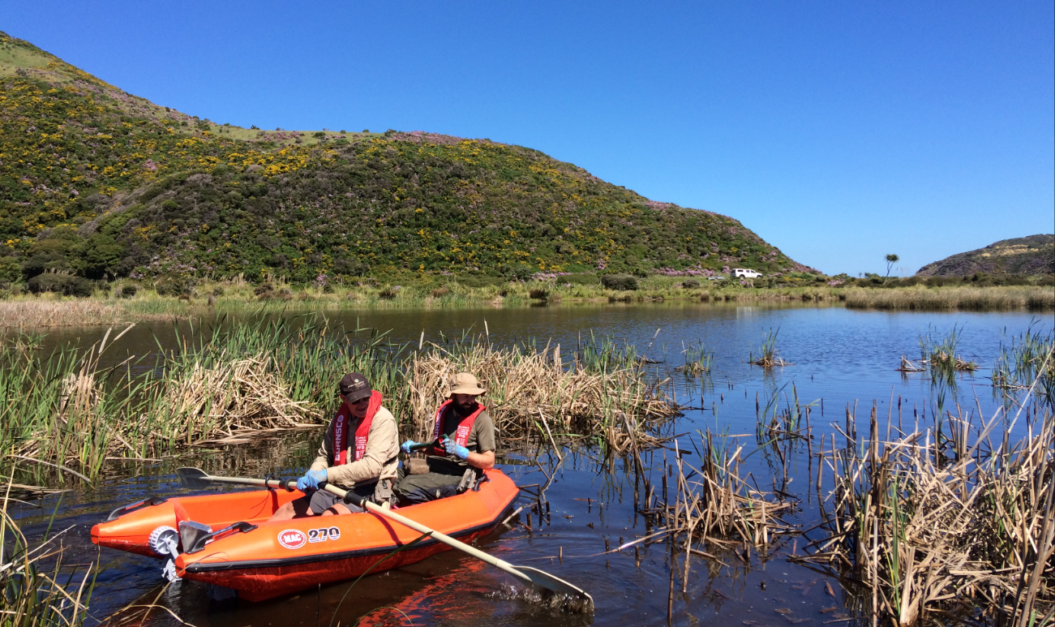
Image 11. Biosecurity department’s field team control yellow flag iris at Lake Kohangatera.
Means of achievement
Co-ordinate site management with other biodiversity initiatives where possible.
Actual performance
In addition to the work that GWRC completed in KNE’s, wetlands and reserves this year, staff worked on a number of other biodiversity initiatives. These included working with:
- The GWRC Biodiversity Department on a range of biodiversity projects including planting
- DOC and the Biodiversity Department on aerial spray operations on alder and willow species around Lake Wairarapa
- QEII and Kiwirail at Taupo Swamp controlling multiple pest plant species infesting this area
- DOC surveying and controlling the pest plant gunnera along the Tauherenikau River, and
- Hutt City Council on controlling boneseed, marram grass, and horned poppy at Parangarahu lakes.

18. Biological Control
Staff worked with 10 different species of biocontrol agents during the year. This work included releasing and transferring agents, and monitoring their establishment and spread.
Monitoring of the green thistle beetle (GTB) continued this year at the five sites, throughout the months October to March. Climatic conditions at these sites were also collected. AgResearch presented on this study at the National Education Training Seminar (NETS2018) in Nelson, July 2018. GWRC staff also assisted AgResearch with harvesting 1,000 green thistle beetles for their research programme. One release of GTB took place in South Makara this year.
Two releases of the tradescantia yellow leaf spot fungus were made. A scientist from Commonwealth Scientific and Industrial Organisation (CSIRO) in Canberra confirmed that the fungus was established at one of the sites, unfortunately there wasn’t any sign seen at the second site. Australia has the fungus in containment and is where NBCC obtained it from but it isn’t approved for release in Australia yet making New Zealand the first country to release the fungus.
Tradescantia stem beetles were monitored at one site, with one stem beetle found showing they are still present. There wasn’t a lot of damage observed indicating they’re not present in big numbers. The stem beetle release site was also inspected with this site having previously shown the most promise with beetles easily spotted on earlier visits. No beetles were seen on this last visit, however, there is still reasonable signs of damage.
One new release was made of tradescantia tip beetle and the damage is noticeable. There was a second release which was added to an existing population.
Staff made 95 transfers of broom gall mites (Aceria genistae) throughout the region and previous release sites were also inspected to prospect for new harvest sites. This agent is becoming well established and is expected to have a good impact on broom as infestations become heavier over time.
Two transfers of buddleia leaf weevil (Cleopus japonicus) were made this year. One to a heavily infested site of buddleia in Paekakariki and another in the Wairarapa. The agent continues to be observed in other areas throughout the region where it is spreading by itself, particularly in the Hutt Valley.
Inspections were made on the two historical release sites of Darwin’s barberry weevil but no weevils were found. They have been found at release sites in Southland which bodes well for our success here long term. MWLCR is to visit in November 2018 to assist looking for the weevils and hopefully confirm establishment in the region. A third release was made in February 2018 at Makara.
As part of the national assessment study on nodding thistle agents (conducted by MWLCR), three sites were inspected in the Wairarapa and Porirua for both nodding thistle crown and receptacle weevils. All the sites had releases of nodding thistle agents in the 1990s and hadn’t been visited for some time. The Porirua site has transformed into construction of Transmission Gully and was unable to be accessed. Nodding thistle receptacle weevil were present at one of the sites in the Wairarapa.
One transfer was made of the Scotch thistle gall fly (Urophora stylata), within the Wairarapa. This agent has been slow to show effects at long-standing release sites.
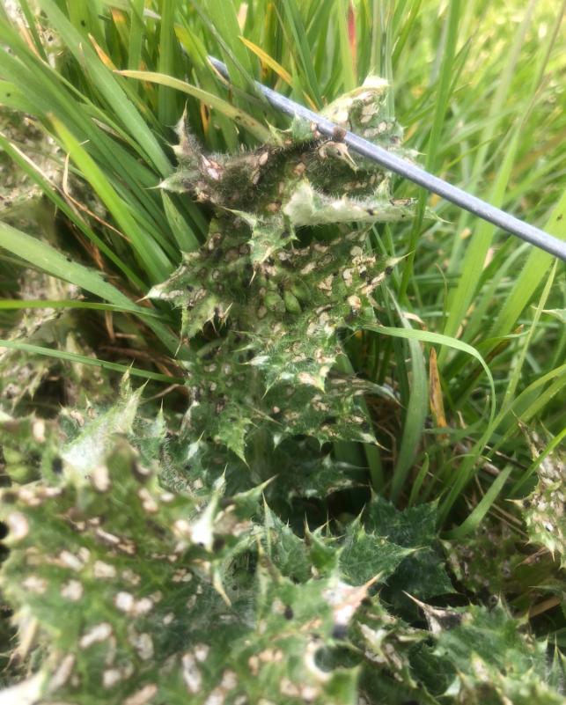
Image 12. Three green thistle beetles and their damage on a Californian thistle at Bennetts Hill monitoring site.
Two more releases of the Japanese honeysuckle Honshu white admiral were undertaken; one release to add to the existing site, and the other at a new site. The second release was sent as caterpillars rather than adult butterflies and it is being monitored to see if this proves a more successful method for establishment. Follow up inspections were done at these sites but neither butterflies nor caterpillars were seen. It is still early days for this project, and the sites are difficult to access so there is some reliance on being there at the right time to spot butterflies. MWLCR will be assisting GWRC in November 2018, to help monitor butterflies (in all their life stages), and identify any damage caused by them. GWRC is responsible for collecting data from other release sites throughout the country for assessment monitoring of the Honshu white admiral. This has begun with baseline information collected from the relevant councils.
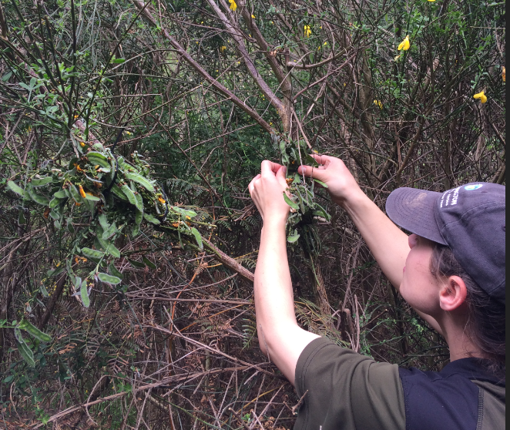
Image 13. Jen McGowan transferring broom gall mite by cable tying infested stems onto broom bushes.

19. National Interest Pest Response Programme (NIPR)
GWRC is part of the Ministry for Primary Industries led national programme to eradicate Manchurian wild rice (MWR) and Cape tulip from New Zealand. GWRC delivers pest plant control management for these two species on behalf of MPI.
There is one site of MWR in the region at Te Harakeke swamp in Waikanae. The swamp was initially surveyed using an unmanned aerial drone after which a helicopter spot sprayed infestations over two operations; the first in December and the follow-up in April. Biosecurity staff undertook ground control in those areas close to housing. Infestations, while significantly reduced in size and number of plants, continue to be very difficult to control, due to changes in the water level, accessibility and infestations being obscured by vegetation.
There are two active Cape tulip sites in the region. GWRC staff inspected these sites on two separate occasions and no plants were found.

20. Public Enquiries
This year Pest Plants staff received and responded to 222 public enquiries, compared to 105 the previous year.
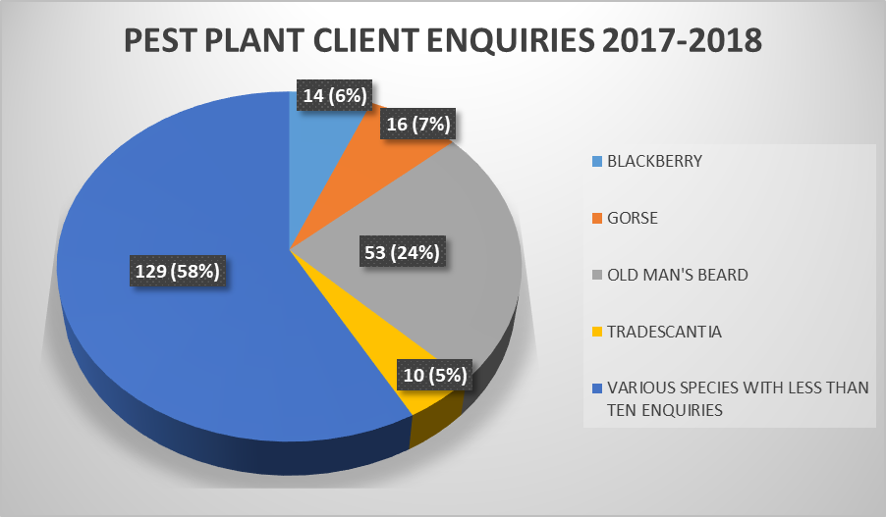
Graph 9. The most common species Biosecurity Officers received enquiries about.

Appendix 1 – Biocontrol agents released in the Wellington Region
Agent species name | First released | Total number of known sites | Overall agent status
Boneseed agents
Boneseed leaf roller | 2007 | 8 | suspect failure
Broom agents
Broom gall mite | 2009 | 800+ | established
Broom leaf beetle | 2009 | 3 | uncertain
Broom psyllid | 1995 | 1000+ | widespread
Broom seed beetle | 1994 | 600+ | widespread
Broom shoot moth | 2008 | 3 | uncertain
Buddleia agents
Buddleia leaf weevil | 2007 | 100+ | established
Darwin’s barberry agents
Darwin’s barberry seed weevil | 2016 | 4 | Uncertain
Gorse agents
Gorse colonial hard shoot moth | 2002 | 5 | failed
Gorse pod moth | 1997 | abundant | widespread
Gorse soft shoot moth | 2007 | 12 | uncertain
Gorse spider mite | 1989 | abundant | widespread
Gorse thrips | 1990 | abundant | widespread
Japanese Honeysuckle
Japanese Honshu white admiral butterfly | 2017 | 2 | Uncertain/first year released
Mistflower agents
Mistflower gall fly | 2001 | 2 | established
Mistflower fungus | 2009 | 1 | established
Old man’s beard agents
Old man’s beard leaf fungus | 1997 | 3 | failed
Old man’s beard leaf miner | 1995 | abundant | widespread
Old man’s beard sawfly | 2002 | 2 | failed
Privet agents
Privet lace bug | 2015 | 1 | failed
Ragwort agents
Cinnabar moth | 2006 | abundant | widespread
Ragwort plume moth | 2012 | 3 | established
Ragwort flea beetle | 1988 | abundant | widespread
Thistle agents
Californian thistle flea beetle | 1994 | 2 | failed
Californian thistle gall fly | 2006 | 1 | failed
Californian thistle leaf beetle | 1993 | 2 | failed
Californian thistle stem miner | 2010 | 2 | uncertain
Green thistle beetle | 2008 | 221 | established
Nodding thistle receptacle weevil | 1972 | 9 | widespread
Nodding thistle crown weevil | 1990 | 4 | established
Nodding thistle gall fly | 2005 | 12 | established
Scotch thistle gall fly | 2005 | 79 | established
Tradescantia agents
Tradescantia leaf beetle | 2011 | 7 | established
Tradescantia stem beetle | 2012 | 10 | uncertain
Tradescantia tip beetle | 2013 | 7 | uncertain
TOTALS: |  | 2905+

Pest Animals team delivered a significant number of additional cost recovery pest control operations for TAs (see table 2)
Pest Plants team made significant saving on the surveillance component of the programme through coordinated surveys for Total Control and Surveillance plants to be included in the proposed Regional Pest Management Plan.
Pest Plants team made significant saving on the surveillance component of the programme through coordinated surveys for Total Control and Surveillance plants to be included in the proposed Regional Pest Management Plan. Also, changes to the control methodology were made for a number of species saving operational time.
Pest Plants team invested significant effort into ground truthing distribution of Containment species to provide reliable information for the RPMP review and changes to the species status going forward (as proposed in the RPMP review).
Pest Plants team invested significant effort into ground truthing distribution of Supression and Human Health species to provide reliable information for the RPMP review and changes to the species status going forward (as proposed in the RPMP review).

